
LESSON – 1
THE BALLOON MAN
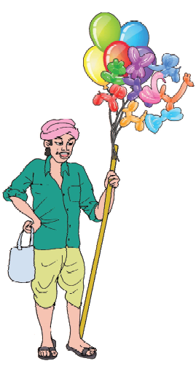
Ramu is a balloon man. He sells balloons. He goes from house to house everyday. One morning he went to a village to sell his colourful balloons.
He called Raju, Bala, Mona, Saif and Sonu and said “I have red, blue, green, orange, yellow and white balloons. Do you want to buy them?” But no one bought them. He was very sad.
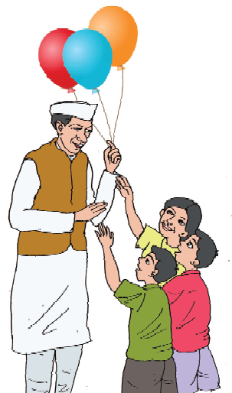
A young man came to him and said,“ What’s the matter? You look sad.”
The balloon seller said, “Yes. I’m here to sell the balloons but no one is buying them today. “Don’t worry. I have come to buy them and I want all the balloons.” The young man bought al l the balloons. Then he gave them to the children. The children were very happy. This young man was ‘Chacha Nehru’.
I. New words
sad, balloon, young, bought, sell, colourful, happy
II. Read and write
Answer these questions:
(1) What does Ramu sell?
(2) Why was the balloon man sad?
(3) Who bought all the balloons?
III. Say aloud
balloon, goes, village, orange, bought, today
IV. Let’s talk
(1) Do you like colourful balloons?
(2) Where do you use them?
(3) Name the colour of the balloon you would buy for
yourself.
V. Vocabulary
(A) Choose the correct spellings :
yuong yonug young yung
balon baloon balolon balloon
yelow yellow yellou ylleow
bought boghut buoght bouhgt.
(B) Complete the following sentences using these

words.
(colourful, balloons, old, happy, today)
1. Mr. Murli is an ________ man.
2. He looks _______ today.

3. He is going to buy __________.
4. _________ is his grandson’s birthday.
5. He wants to decorate his room with _________
balloons.
VI. Structures in context
(A) Underline the correct word in the given sen
tences.
1. This is Mrs. Suman. He/She is my class teacher.
2. Ravi is a student. He/She reads in class 3.
3. Raju buys a balloon. He/It is blue in colour.
4. I play with Sita, Meena and Sunil. She/They are
my friends.
5. I have a little dog. It/ They is very cute.
(B) Make negative sentences :
1. Ramu is a balloon man.
2. I am a student.
3. I can run fast.
4. I have come to buy balloons.
5. These are my balloons.
(C) Make interrogative sentences :
1. Ramu is a balloon man.
2. Children were playing in the garden.
3. The man had come to buy the balloons.
4. A young man bought all the balloons.
5. The young man was Chacha Nehru.
VII. Fun time
Riddles
1. What has a face and has two hands?
2. What has a neck but no head?
3. If there are three apples and you take away two, how many do you have?
4. Which month has 28 days?
5. Where does friday come before thursday?

Complete the crossword with the opposite of the given words.
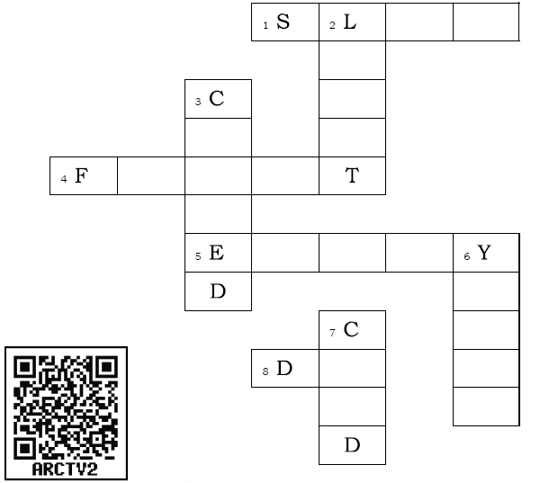
Across
1 Fast
4 Back
5 Late
8 Up

Down
2 Dark
3 Open
6 Old
7 Hot

LESSON - 2
SATTU GOES SHOPPING
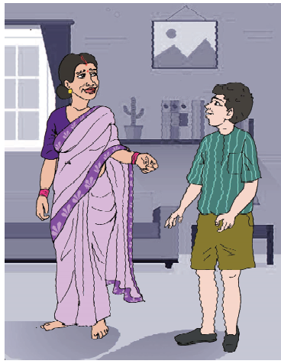
Sattu : Maa, Maa, we have a cricket match today.
May I go out to play?
Mother : You may. You must finish your homework first.
Sattu : I have done my homework.
Mother : Then, please help me with the shopping. Go to the
market and buy some sugar, soap and vegetables for me. Here is the shopping list-

sugar - 1 kilo
soap - 1 bar
spinach - 2 kilos
biscuits - 1 packet
banana - 1 dozen
oil - 1 litre

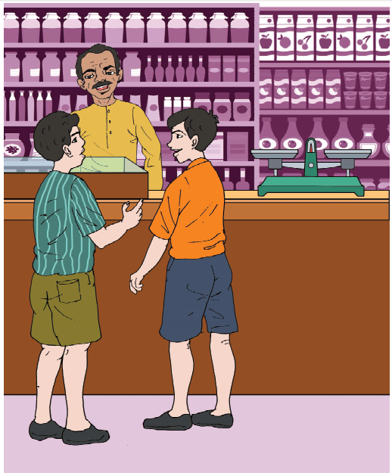

Raju : Hello Sattu, where are you going ?
Sattu : I am going to the market.
Raju : May I come with you ?
Sattu : Yes, you may.
Sattu : Uncle, please give me these things.
(Sattu gives the shopping list to the shop keeper.)
Shopkeeper : Here you are. But I am sorry I don’t have biscuits and spinach.

Sattu : Sattu and Raju go to the green grocer.
Uncle, please give me 2 kilos of spinach.
Shopkeeper : Here you are.
(Sattu and Raju return home)
Sattu : Maa, we bought your things.
Mother : Thank you. Did you get all the things in the
list ?
Raju : We couldn’t get biscuits.
Mother : Where is the spinach ?
Sattu : Oh, look at the cow..... .
I. New words
green grocer, spinach, shopping list, buy
II. Read and write
(A) Answer these questions :
1. Who went to the market?
2. How much sugar did Sattu buy?
3. Who ate the spinach?
4. How many bars of soap did Sattu buy?
(B) Put the events in proper order according to the story:
(i) The cow ate up the spinach.
(ii) Mother gave a shopping list to Sattu.
(iii) Sattu went to the market.
(iv) Sattu gave the shopping list to the shopkeeper.
(v) He bought 2 kilos of spinach.
(vi) Sattu and Raju went to the green grocer.

III. Say aloud
vegetable, biscuits, spinach, grocer

IV. Let’s talk
(1) Do you go to market to buy vegetables, fruits or other things? Tell the class the vegetables you buy.
(2) Do you go alone or with someone?
(3) Make the list of things you want to buy from the village or city market and read it aloud.

V. Vocabulary
(A) Look up the dictionary and find the differences between the following. Write the meanings in the given space.
(i) a grocer a green grocer
..................... .....................
..................... .....................
(ii) soap paper soap
..................... .....................
..................... .....................
(iii) ear eardrop
..................... .....................
..................... .....................
(iv) paper paper weight
..................... .....................
..................... .....................

(B) Separate the things which Mohan will buy in kilos and by count.
rice
potatoes
pen
sugar
bananas
match box
spinach
(C) Match the columns.
A piece of bananas
A bar of biscuits
A kilo of paper
A dozen of soap
A packet of oil
A litre of sugar
(D) Which of these are countable?
chairs, lemons, paint, tea, cup, bedsheets, water,
water bottle
VI. Structures in context
Use ‘may’ and make five polite requests.
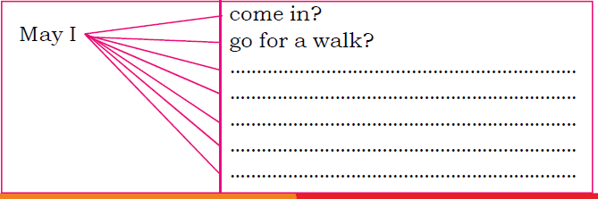
VI. Let’s speak and act
Make small groups with your friends. In every group one
of you could become a shop keeper and the others can
become customers. Act out your roles.
Make a role play of this lesson.
Customer : Please give me 1 kilo of sugar.
Shopkeeper : Here you are.
Customer : Thank you.
Shopkeeper : You are welcome.

At the grocery shop
1. Good morning, Uncle/ Aunt.
2. Good morning, .................... (Name of the student).
Yes, please.
1. I want some grocery items.
2. Do you have the list?
1. Oh yes. Here it is. I want these three items.
2. Wait a minute. ( after 5 minutes) Here you are.
1. Thank you, Uncle.
2. You are welcome. Do visit the shop again.
VII. Fun time
(A) Complete the poem with words for the pictures.
I have a  For my cute little 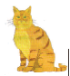
She lives in my  And run after the 
She likes a of milk And the little of silk

(B) Say these sentenes/phrase repeatedly :

1. Bitter butter.
2. Black back bat.
3. She sees cheese.
4. Good blood, bad blood.
5. I scream, you scream, we all scream for ice-cream.
6. I saw a kitten eating chiken in the kitchen.
VIII. Activity (Words from a word)
Make meaningful words with the letters of the word given below.
For example: TEACHERS
One letter words: A
Two letter words: AT, HE
Three letter words: SHE, HER, TEA, RAT, HAT, EAT, ACT,
Four letter words: EACH, CHAT, HEAT,
Five letter words: TEACH, CHEAT, REACH, SHEET, TREAT
Six letter words: CREATE

Now make as many words as you can from the word given below.

POTATOES
(Note: You can use letters only from the given word. You can use a letter as many times as it comes in the given word.)

LESSON - 3
THE FIS H AND THE DUCK

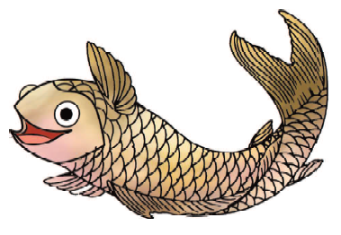
Miss Bambi, the fish, was merrily swimming with her friends. She saw Sumit sitting on the shore. His fishing line had a juicy bit of earthworm on the end. Bambi said to herself, “What a tasty trap”. She went to all the fishes and said, “Let’s go some where else or we will be eaten up”. Then she found a shell, a King Shell and hung it by the hook.
Sumit said, “I think, I have a big fish on my hook. Let me pull it out. What's this? It is a King Shell, not a fish. How unlucky I am!”
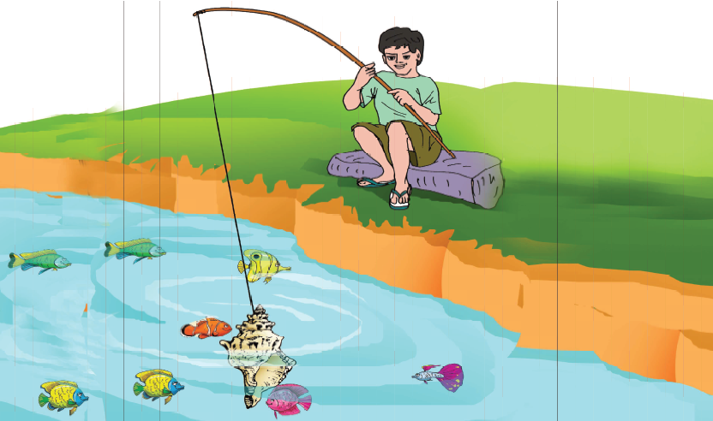
Bambi had a good laugh. —Ha – Ha – Ha .
Ducky Duck saw Bambi and paddled to her.
Ducky Duck said,“ You are very clever, Bambi. Come, be
my friend.”
Bambi said, “Thankyou Mr.Ducky Duck. But I think I am
too young to play with you. I am also late. I must run home.
Bye!”

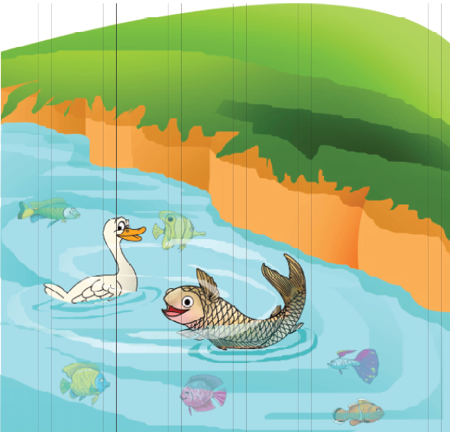

I. New words
push, shore, sheep, sea, seek, sell, earthworm, shell
II. Read and write
(A) Answer these questions :
1. What was Sumit doing?
2. What was Bambi doing?
3. What did Bambi put on the hook?
4. Why was Sumit unhappy?
5. What did Ducky Duck really want?
(B) Who said:
“What a tasty trap”.
"It is a king shell not a fish. How unlucky I am!”
"You are very clever Bambi. Come , be my friend.”
"But I think I am too young to play with you."
III. Say aloud
merrily, shore, juicy, earthworm, paddled, shell
IV. Listen and repeat
sea - she, sell - shell, sore - shore, sit - shit
V. Let’s talk
(A) Twist your tongue :
She sells sea shells on the sea shore.
Note : The teacher will help the learners pronounce the words correctly.

(B) 1. Was Bambi clever? How can you say that?
2. Did the duck really want her to be his friend?
3. What would have happened if Bambi had gone to play with the duck?

VI. Vocabulary
(A) Find the correct antonyms from the bracket and write them.
(over, near, push, bottom, young)
1. top ....................................
2. under ....................................
3. far ....................................
4. old ....................................
5. pull ....................................

(B) Movement of animals :
(swim, fly, crawl, flutter, climb)
1. snail ..........................
2. fish ..........................
3. birds ..........................
4. monkey ..........................
5. butterflies ..........................

VII. Structures in context
(A) Sort out all proper and common nouns from the lesson and write them in the table.
Proper noun | Common noun

Note : The name of a person, place, animal or thing is called a noun. The names by which we call common things around us like animals, schools, instruments are called common nouns. Similarly the names by which we know people, countries, towns, rivers, pets, months, days, etc., are called proper nouns. They begin with a capital letter. Sumit, India, Chhattisgarh, Raipur, January, Thursday etc., are all proper nouns.

(B) Look at the examples and make exclamatory sentences:
I am very unlucky. How unlucky I am!
He is very clever. How clever he is!
This is a beautiful painting. How beautiful painting this is!
You are very smart. .......................................
They are very strong. .......................................
The book is very interesting. .......................................

IX. Fun time
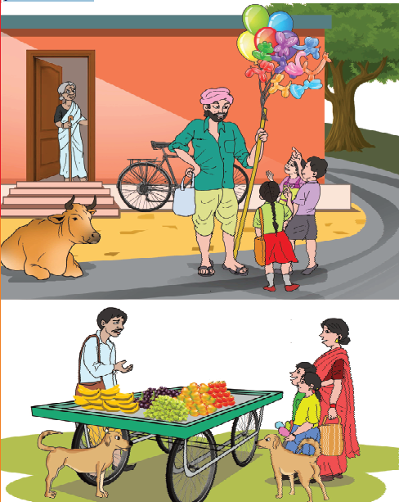
(A) Look at the picture and write about the activities you see in it.

(B) Complete the rest of the story with these four words.
tree, mango, parrot, monkey
One day a parrot saw a mango in a tree. The parrot flew towards the mango. He saw a monkey. The monkey said to the parrot, “Don’t touch the mango. It is mine.” The parrot said, “Brother .........! I am very hungry. Please let me eat half of the ...........” The ............ agreed. Together they ate the.............. . Thus the ............... and the ................. became friends.
X. Activity -Word chain
Teachers can give this activity as an individual or group task. Teacher will write a word on the blackboard and ask the students to keep on adding words which start with the last letter, Teacher will allot time to the students and ask them to present it before the class as soon as they finish the task.
M A N
E
T I M E
A
R O A D
O
W
N O R T H
(Do not use proper nouns.)

LESSON – 4
CATS
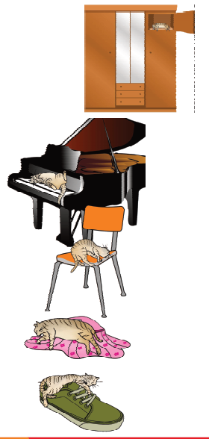
Cats sleep
Anywhere,
Any table,
Any chair,
Top of piano,
Window - ledge,
In the middle,
On the edge,
Open drawer,
Empty shoe,
Any body’s
Lap will do,
Fitted in a
Cardboard box,
In the cupboard
With your frocks
Anywhere!
They don’t care!
Cats sleep
Anywhere.

I. New words
ledge, edge, drawer, fitted, cupboard, empty, card board
II. Read and write
1. Name the places where cats sleep?
2. Write down the names of things in the poem.
3. Write three sentences about cat's.
III. Say aloud
piano, window- ledge, edge, drawer, empty, fitted,
cupboard, anywhere
IV. Let’s talk
1. Do you have any pet animal in your house?
2. If yes, name the pet animal.
What does it eat?
3. Where does it sleep?
V. Vocabulary
(A) Fill in the blanks with suitable words :
(cupboard, edge, empty, fits, drawer)
1. You have put the glass of water on the …………… of
table. It may fall down and break into pieces.
2. Please open the …………… in the table. Do you find any pen in it?
3. No, I don’t. There is nothing in it.. It is …………..
4. Where is the …………….. I want to put this box there.
5. The size of the box .......... well in the cupboard.

(B) Match the rhyming words:
(A) (B)
sleep care
where keep
table pair
chair ox
box edge
ledge pot
cot cable
(C) Make new words using ‘at’. Add one two or three letters before ‘at’.
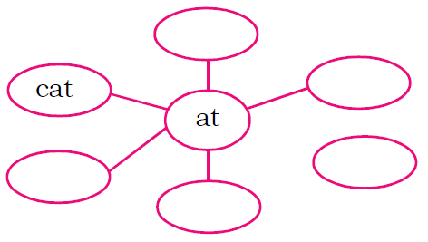
(D) Make new words using ‘en’.
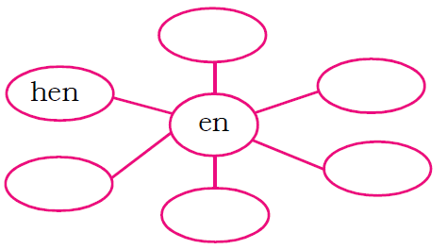
Write the correct phrases below the given pictures
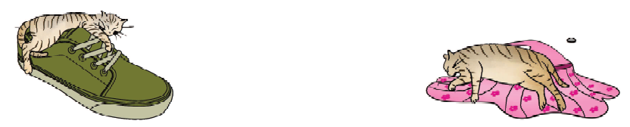
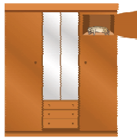
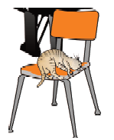 | 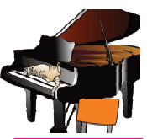

on the top of piano
on a chair
in the cupboard
on the table
in an empty shoe

VI. Fun time
(A) Colour the cat
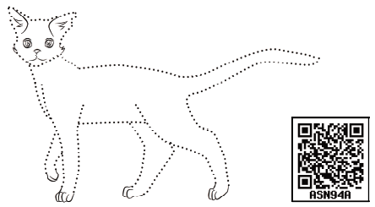

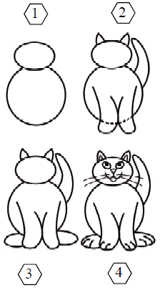
(B) Follow the instructions and draw the cat:
1. Draw a small circle for the face and a big circle for the body of the cat.
2. Draw two ears, one tail, and two legs as shown in figure 2.
3. Draw two back legs and erase the dotted lines in figure 2
4. Draw eyes, nose, mouth and whiskers.
Is your drawing ready?
Say “Meow”.

LESSON - 5
AT THE PLATFORM
Tripti, Tara, Rupa, Sneha, Sahil and Joseph are all at the station. Lata is coming today. Her train is late. It is coming at 10 o’clock. It is 9 o’ clock now. So they are on the platform waiting for her.

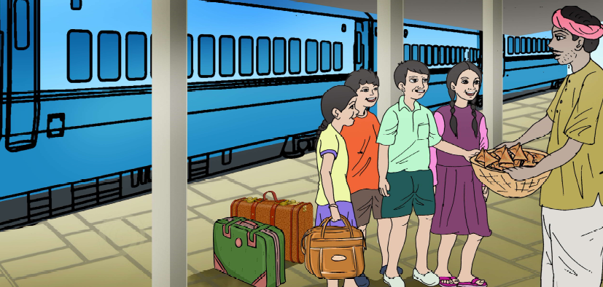
Tripti : I am hungry. I will eat some samosas. Come, who wants to eat.
Joseph : I am hungry too.
Sahil : Me too.
Tara : This food is not clean. It has dirt on it. Look at all
those flies. You should not eat these. Let’s buy some bananas.
Geeta : I have my tiffin. You can have my idlis and chutney.

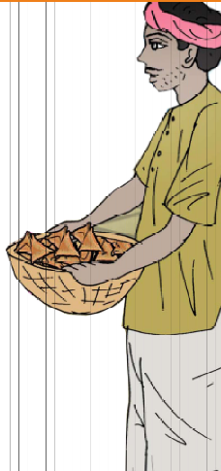
All together : Oh, yes that will be great.
Rupa : Oops! I dropped one. I am sorry.
Tripti : Thank you Geeta.
The idlis are very tasty.
Here comes the train.
Joseph : Look, look, there is Lata.
Lata : Hello! everybody.
Sahil : Her bags are heavy.
Sneha : May I help you?
Lata : Thank you. Yes please.
Rupa : Welcome, Lata. How are you?
Lata : I am fine. Thank you. Come, let us all go home.
I. New words
station, hungry, clean, dirt, dropped, heavy, please

II. Read and write
Answer these questions:
1. Who is arriving by the train?
2. When is Lata’s train coming?
3. Why is the food on the platform not clean?
4. How does Sneha help Lata?
III. Say aloud
platform, hungry, dirt, flies, tiffin, dropped, tasty.
V. Let’s talk
1. Have you ever seen a railway platform?
2. What different sounds do you hear there?
3. Recall and repeat the railway announcement if you
ever heard.
VI. Vocabulary
(A) Complete the sentences with the help of the given
words :
hungry, dirt, station, platform
We reached the railway........................... . We did not have to wait long for the train. It reached the ...................... just after 10 minutes. I wanted to eat something because I was ..................... So my Papa bought some fruits. He washed
them and said, "Now the fruits are free from .............. and
flies and you can eat them." We enjoyed the fruits and the
journey.
(B) Write the names of the means of transport :
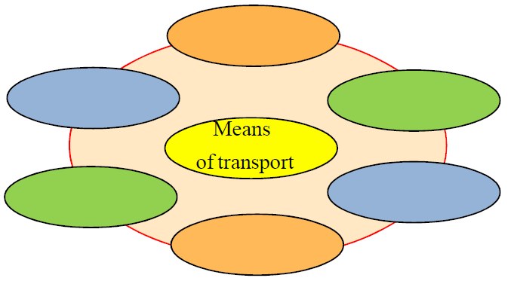
(C) Read the sentences and tick () in the boxes of do’s and don’ts:
 |  | Do’s Don’ts
1 | Be rude to others.
2 | Say sorry when you hurt someone.
3 | Wash your hands before eating
4 | Tell a lie.
5 | Comb your hair everyday.
6 | Eat uncovered things.
7 | Wish your elders.
8 | Hurt birds or animals.

V. Structures in Context
(A) A and an, are articles. They are used before singular countable nouns. ‘a’ is used before nouns beginning with consonant sound and ‘an’ before nouns beginning with vowel sounds.
Add article-a/an:
1. ................. owl 6. ................. umbrella
2. ................. papaya 7. ................. girl
3. ................. flower 8. ................. ox
4. ................. egg 9. ................. ship
5. ................. engine 10. ................. boy

(B) Fill in the blanks with must, is, are, have, has, doesn’t :
Tripti .... hungry. There ...... samosas to eat but Tara ........... want to eat them. Geeta ...... idlis in her tiffin box. She said,”We ....... eat clean food only.”
(C) Match and join the sentences to make meaningful expressions :
I dropped the idli. If you are hungry.
Let’s buy some guavas. Now, get ready.
You can have my idlis. Mummy will be waiting for us.
Here comes the train. I am sorry.
Let us go home. Fruits are very fresh there.
Write a small paragraph of about 40 words on the following topic with the help of words given in the help box.
At the Railway Platform:
As we reached the .................., we went to the ………….. to get the …………..first. On the ………….. there was a great rush of ………….. . There were ………….. carrying …………on their head. The …………..were selling their .......... at the top of their voice, “Chai, chai, chai garam, ice-cream, ice-cream, cold drinks, thanda, samose garam. We were listening to the ............................ about trains.
Help-box
railway staion booking-window passengers
coolies platform
luggage hawkers goods
tickets announcements
VI. Activity
Listen to the railway announcements carefully and answer the questions.
• Train No. 12860, Geetanjali Express scheduled to arrive on platform number 1 at 3.10 a.m. is running late by 35 minutes.
• Train no. 12809, Mumbai-Hawrah Mail scheduled to arrive at 4pm is running on time. It is going to arrive on platform no. 2 shortly.
• Train no. 1046 Shivnath passenger scheduled to arrive at 4.20 pm on platform no. 3 is arriving soon.
• Train no. 1222, Raipur - Korba Superfast has just arrived on platform no. 5.
• Raipur Railway Station welcomes you.
• Please take care of your luggage.
• Please do not get down from a moving train.

• Write the train number of Geetanjali Express.
• Which train is arriving on platform no.2.
• Write the name of the train which is late.
• Which railway station is this?

• Teacher may change the name of trains and numbers.
VII. Listen and repeat
Chuff - Chuff
Puff - Puff
Here comes the train.
The engine is its brain.
Chai - Chai, Chai garam
The vendors run along
Mintu sits at the window
Watching all day long.
VIII. Fun time
If possible, go to the nearest railway station. Listen to the sound and activities you come across there and talk about it.
Label the diagram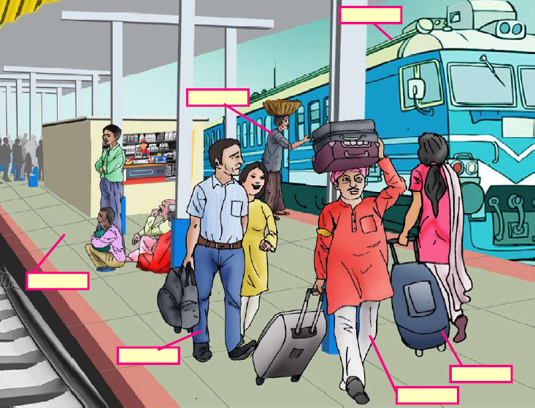

IX. Activity - Word ladder
- Make a word ladder. Each word you use should start with the last letter of previous word and each word of the ladder must have only four letters.
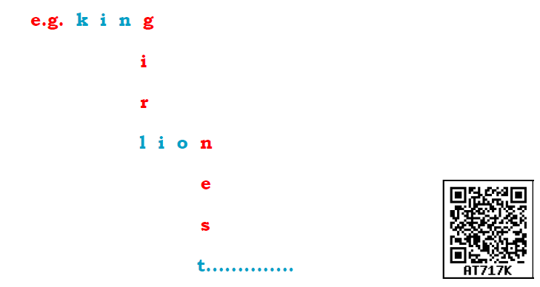

Teacher can give this activity as an individual or group task. First he may allow the students to consult the text book of any class with the condition that they must know the meaning of the word they use in the word ladder. Ask individual or a group to present it before the class.

- Write the words which are closely related to a railway station.

For example : trains, passangers, berth, coach, ........ .................................................................................

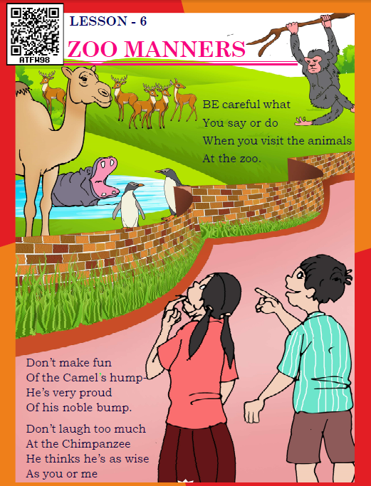

And the Penguins
Strutting around the lake
Can understand
Remarks you make.
Treat them as well
as they do you,
And you’ll always be welcomed
At the zoo.
Eleen Mathias
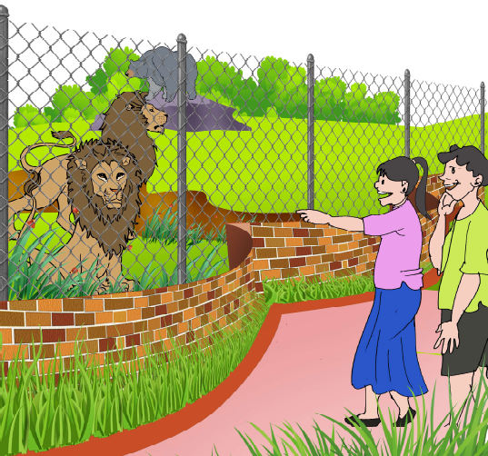

I. New words
proud, noble, wise, ,penguins, strutting, remarks

II. Read and write
Answer these questions:
1. What should we do when we visit a zoo?
2. Which animal has a hump?
3. Which animal thinks he is as wise as we are?
4. What can these animals do? Complete the sentences.
(i) The camel can ................................ .
(ii) The chimpanzee can ............................... .
(iii) The penguins can .................................. .
5. Write the message of the poem on your notice board.
III. Say aloud
careful, animals, proud, hump, chimpanzee, penguins ,
strutting, remarks, treat, always, welcomed
IV. Let’s talk
1. Have you seen a zoo?
2. Name the animals you saw in the zoo.
3. Which animal do you like most? Why?
V. Vocabulary
(A) Fill in the missing words to form names of animals and birds:
l - - - ti - - r
w - - f d - - r
j - c - - l o - -
mo - - - y b - - r
(B) Guess who they are and write their names :
1. I can’t sing but I can fly.
I am very colourful.
Children love me and I love flowers.
I am a ...................... .
2. I can fly. I sit on food and also on dirty places.
I am a .................... .
3. I have four legs, I have a hard shell.
I am a ................... .
4. I am tiny, I live under the ground.
I like sugar.
I am an ................... .
5. I have wings but I am not a butterfly.
I go buzzing ‘buzz’.
(C) Use these words to complete the following sentences:
(Penguins, treat, wise, struts, zoo, hump)
1. A lump on the back of animals is .............. .
2. We can see wild animals closely at the ........... .
3. .......... can understand your comments.
4. Chimpanzee thinks he is as ............ as you.
5. If you .......... the animals well, you will always be welcomed by zoo.
6. He is vey thin but he ............ like a wrestler.
(D) Make meaningful sentences by connecting parts in column A and B
Column A | Column B
1. Parents feel proud  2. My teacher checks our  notebooks  3. It is your wise decision  4. It’s bad  5. My parents visit my school | to make fun of others.  for parent’s - teacher meeting.  when you get good marks.  and write remarks.  to buy a bicycle for your son.

VI. Let’s listen
Listen and put a tick ( ) against the words that the teacher says :
it at
think thank
fun fan
much match
well wall

VII. Fun time
Let’s sing together

Have you ever heard or sung an English song. Sing with your teacher.
We shall overcome
We shall overcome
We shall overcome
We shall overcome some day

Oh, deep in my heart
I do believe
We shall overcome some day

We’ll walk hand in hand
We’ll walk hand in hand
We’ll walk hand in hand some day

Oh, deep in my heart
Ido believe
We shall overcome some day

We are not afraid

We are not afraid
We are not afraid some day

Oh, deep in my heart
I do believe
We shall overcome some day
Teacher can download this and other English song easily and make students hear through his/her mobile.


LESSON – 7

THE SKY IS FALLING

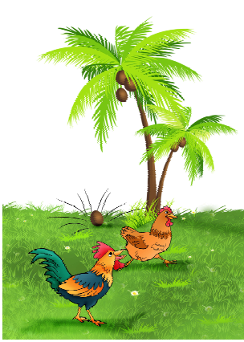
Kut-kut Kutak Koo,
a hen was standing near
the coconut tree. A nut
fell down from the tree,
‘Dham!’ She said, “Kutkut-kut-kutak koo, the
sky is falling! The sky is
falling!”, and she ran.
The cock asked,
“Why are you running ?”
The hen said, “Run,
the sky is falling.”
The cock said,
“I am also coming with
you”. So they ran
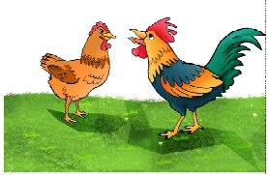
together.
On the way they met a
duck
The duck said,“Quackquack,
why are you running?”
The hen said,“Run, run,
Kut-kut kutak koo, the sky
is falling!!”

The duck said,“I am also coming with you”
And they ran together.
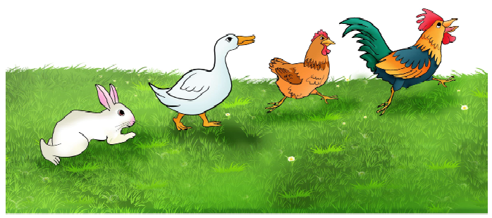
A rabbit saw them running.
Rabbit,“Where are you going ?”
The hen said,“Run, run, the sky is falling.”
So they all ran together.
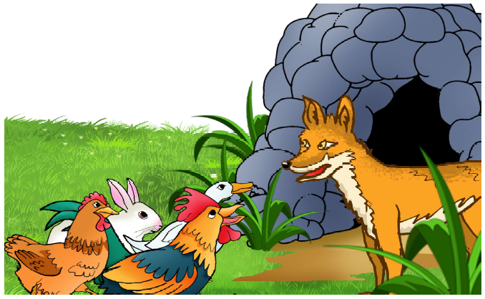

A fox was coming out of her cave.
She asked, “Oh! my dear, what is the matter ?”
The hen said,“The sky is falling, we are all going
to the king’s palace.”
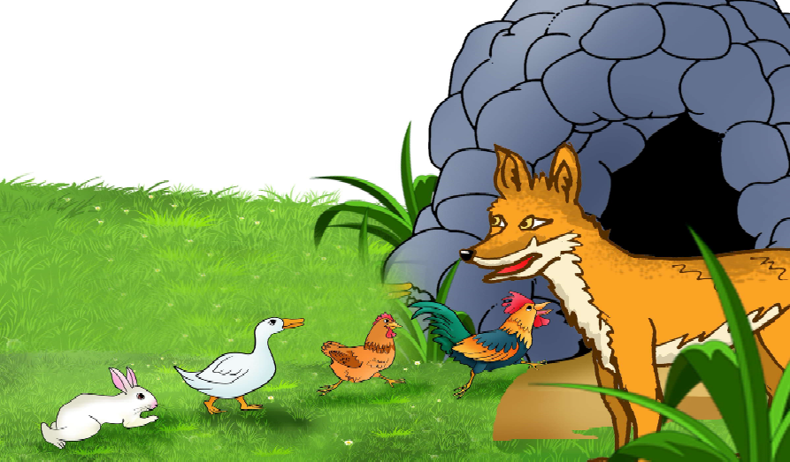

The fox said,“Friends, I know the king’s palace.
I will take you there.
The hen said,“Yes, yes.”
The fox went into the cave and the hen, the cock,
the duck, the rabbit, went into the cave one by one.
Guess what happened then _ _ _ _ _ _?
I. New words
together, fox, palace, cave, sky, guess
II. Read and write
Answer these questions.
1. What fell from the tree?
2. Who said “The sky is falling”?
3. Where did the fox take them?

III. Let’s talk
Think about the story what happend next and share
with your class.
IV. Vocabulary
(A) Complete the table using words given in the box.
1. Names of 4 pet animals.  2. Names of 4 wild animals.  3. Names of 4 birds. | dog, zebra, lion, cow,  deer, crow, cat, parrot,  sparrow, pigeon, goat, fox

Pet animals | Wild animals | Birds
goat | zebra | pigeon
(B) Find the meanings of the words using the dictionary.
palace shed kennel
cave cottage stable
(C) Match these pairs of words with similar sounds.
hump make
lake bell
well bump
much bun
fun sound
round such
V. Structures in context
Make questions to get these answers.
1. I am going to Raipur.
2. I am not going to school because I am ill.
3. They will reach here in the morning.
4. He is reading the story.
5. I am fine.
6. This is his book.
VI. Read the paragraph given below
Pola is an important festival of Chhattisgarh. On the day people decorate and worship bulls. Children play with Nandi bull made of clay.
Similarly write a paragraph on your favourite festival.
Hints : Where is the festival celebrated?
When is it celebrated?
Why is it celebrated?
How is it celebrated?
VII. Activity: Let’s act
Make a role play of this lesson. Teacher will divide the students in groups. The number of students in a group will be according to the number of characters in the story. Teacher will ask the students to speak their dialogue with proper voice modulation. Each group will present their roleplay before the class.
VI. Fun time
Let’s listen
Make all your friends sit in a circle. Whisper a secret in your partner’s ear. Your partner will in turn whisper the secret into the ear of the student on his right. Pass the secret on till it goes around the circle. The last child will tell the secret aloud.
Is the secret the same as you said in the beginning.
eg. I have seen a parrot with red spots.
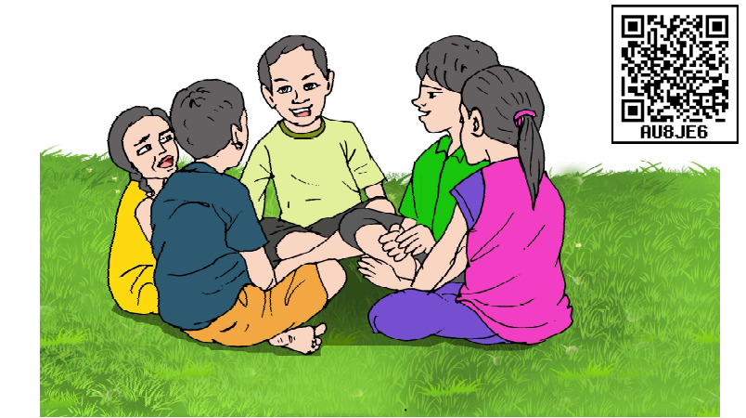


LESSON – 8

WAKE UP!

Wake up! Wake up!
It’s a lovely day.
Oh! Please get up
And come to play.
The birds are singing in the trees,
And you can hear the buzzing bees.
Wake up! Wakeup!
It’s a lovely day.
Oh! Please get up
And come and play.
It’s much too late to lie in bed,
So hurry up, you sleepy head.
Wash and dress
And come on out –
Everyone is up and about.
The cow, the horses, the ducks
And the sheep,
The tiniest chicken
Cheep-cheep-cheep
Wake up!
– C. Fletcher

I. New words
wake up, lovely, buzzing, sleepy head, tiniest
II. Read and write
Complete the answers:
(i) By what name does the poet call the child?
The poet calls the child .................. .
(ii) Is it too early for the child to get up?
No, it is too late to ............... in bed.
(iii)Name the animals & birds who are already awake?
The ............................... are already awake.
(iv)What does the poet ask the child to do before
going out?
The poet asks the child to .......... and ......... .
(v) Who are the tiniest ones to get up?
The tiniest ones to get up are the .............. .
III. Let’s talk
(A) 1. Do you get up early in the morning?
2. Who wakes you up?
3. How does he or she wake you up?
(B) (i) The children are playing in the playground.
They are playing football.
Say the instructions or sentences that they use:
e.g. Hit the ball!
Pass the ball!
Don’t cross the line!
Give it to me!
Run fast!
Run, run, run!
Write such instructions which are used in cricket.
________________ _______________
________________ _______________
________________ _______________
(C) Talk about yourself.
Tell the class when do you get up?
What do you do in the morning?
Who wakes you up?
What happens when you get up late?

IV. Vocabulary
(A) Fill in the blanks with suitable words given in the box.
wakes, lovely, hurry, buzzing
1. You have a _________dress.
2. I don’t like the ___________ sound of bees or dragonflies.
3. ________up or we will be late.
4. My grandmother _________ me up everyday.

(B) Match the words and make meaningful instructions:
A B
Get quiet.
Go brave.
Keep hard
Work ready.
(C) Match the meanings with the phrases according to the poem
much too late - someone who is fond of sleeping
come on out - awake and moving
up and about - very late
sleepy head - get up and come out
IV. Write and share
What does your mother say to wake you up? Can you add some more lines which she says to you?

Wake up,  my child! | Look! the sun has risen.
 | Leave the bed, you will be late for your school.
 | Look what I am cooking for you.
 | Look! what a pleasant weather outside
 | ________________________________________
 | ________________________________________

V. Structures in context
(i) Write some instructions which have only two words. Go through the textbook of class IV, note down such instructions. Share them with your class. Learn from your teacher how to use them.
e.g. Wake up. Come in.
(ii) Connect the pairs of sentences below using ‘and’.
(a) It is 10 ‘O’ clock.
(b) It is the time to go to bed.
_____________________________________________
(a) Meera studies well.
(b) She helps her mother in the kitchen too.
_____________________________________________
(a) I wrote a message.
(b) I sent it to my all friends.
_____________________________________________
(a) I wake up early in the morning.
(b) I go for morning walk with my father..
_____________________________________________
(iii) Choose the correct word and fill in the blanks.
(a) .......... a fine morning. (It’s/Its)
(b) I have a cow . .......... colour is brown. (It’s/Its)
(c) The Tajmahal is famous for ........ beauty. (It’s/Its)
(d) This is plastic chair so ........ very light in weight. (It’s/Its)
(e) This school is known for ........ building. (It’s/Its)
(f) Don’t go outside withour warm clothes ........ very cold today. (It’s/Its)

VI. Fun time
- Now twist your tongue Divide the class into four groups. Give one tongue twister to each group and ask to present before the class.
Note: Teacher will help the learners to pronounce correctly:

- Upper roller, lower roller
- Good cook could cook
- Slim slam slap
- Thin sticks, thick bricks
- Look at the picture and write about it.
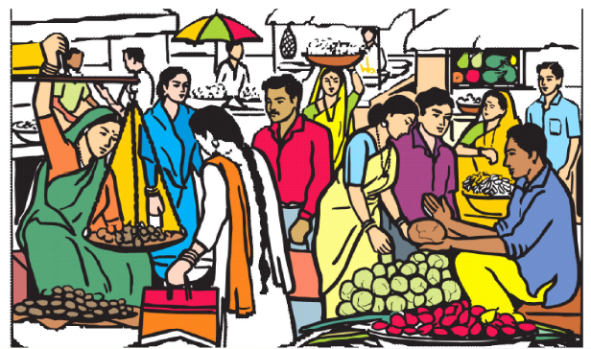

LESSON – 9

I WANT
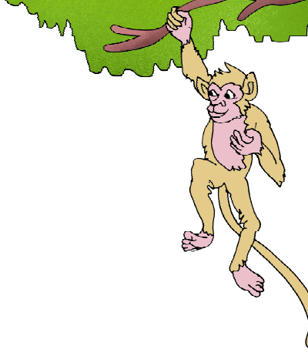
“I want to be big,” says
Little Monkey. “I want
to be strong.”
A wise woman hears
him. “Take this magic wand,”
she says, “and all your
wishes can come true.”
A giraffe comes by. He stretches his long
neck. He eats the sweet leaves at the top of
the trees.
“I want a long neck,” says Little Monkey.
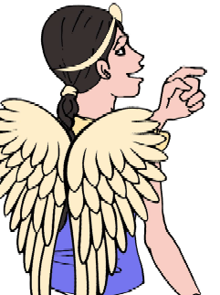
“POP!”
His neck grows long, just like the giraffe’s. Little Monkey is happy.
An elephant comes down to the river.
He fills his trunk with water.
He blows it all over himself.
“I want to do that too!”,
says Little Monkey. “BANG!”

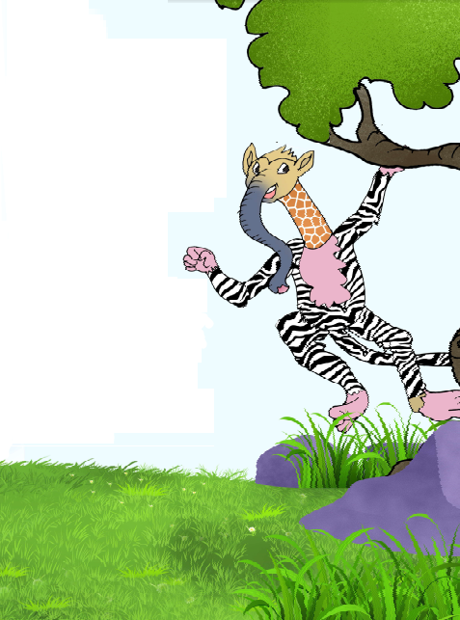
Just like that, he grows
a trunk.
He is very happy. “This is fun!”
he says.
Next, Little Monkey sees a zebra.
“I want stripes like those,”
he says. “WHIZZ!”
Little Monkey has stripes
all over his body, just like
the zebra.
He is very, very happy.

He goes to the river to
try out his new trunk. He
looks down.

He sees himself in the
water. “Mother!” he cries.
“Help! A monster!”

“That’s not a monster,” says his mother. “That’s you.”
“You want a giraffe’s neck, an elephant’s trunk and stripes like a zebra. Don’t you remember?”
Little Monkey cries and cries. “I look AWFUL!” he says. “I want to be myself again.”
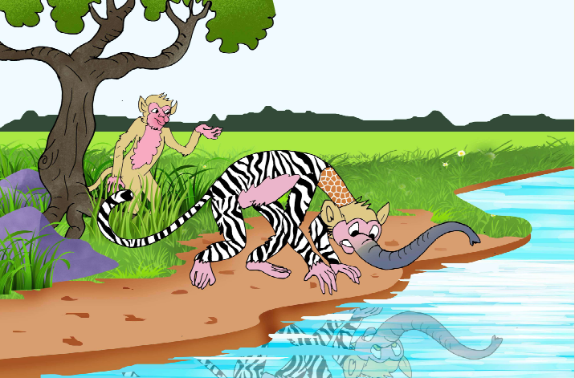

There is a POP, a BANG and a WHIZZ.
Little Monkey is himself again. He jumps for joy.
He throws the magic wand into the river.
He never wants to be anyone else again.

I. New word
strong, wand, wishes, blows, trunk, monster

II. Read and write
(A) Answer these questions:
1. What were the monkey’s first three wishes?
First wish | Second wish | Third wish
I. New word
strong, wand, wishes, blows, trunk, monster
II. Read and write
(A) Answer these questions:
1. What were the monkey’s first three wishes?
First wish Second wish Third wish
2. How did he look ultimately?
3. Was he happy with his looks?
4. What was his wish?
(B) Put a (_ ) or a (x) against the following
sentences.One has been done for you :
1. The little Monkey wants to be big and strong. (_)
2. A wise man gives him a wand.
3. The giraffe gives his long neck to monkey.
4. The elephant cannot fill water in its trunk.
5. The zebra has stripes.
6. The little Monkey sees a monster in the river.
III. Say aloud
magic, wand, hears, wishes, streches, eats, blows, stripes, monster, awful

IV. Let’s talk
1. What would you do if you had a magic wand? Tell your
first three wishes to your class.
2. Do we learn a lesson from this story? What is it?

V. Vocabulary
(A) Use the words in your own sentences :
wish, river, remember, monster, magic, wand

(B) Make meaningful words with jumbled letters :
ndaw ............, pypah ..........., cigma .............,
iltetl ............, odyb .........., ertaw ..............

VI. Think and write
1. My favorite animal is ....................... . I like it because
..............................................................
2. My favourite bird is .................... . I like it because
.............................................................................
3. I want a magic wand because ....................
..............................................................................
4. I do not want a magic wand because ............................
..............................................................................

VII. Structures in context
(A) Punctuate the following sentences using capital letters,
comma, fullstop and question mark appropriately :
1. i am a man
2. what is your name
3. ankit rahul and rohit are my friends
4. i study in class III
5. he and i are good friends
6. he said i am very happy

(B) Make three sentences like the sentences given in
bracket.
1. I want ............ ( e.g. I want breakfast.)
2. I want to ........ (e.g. I want to play cricket.)
3. I want to be .......... (e.g. I want to be a singer.)
Replace the unerlined italic words with appropriate ones and
make more such sentences.

VIII. Fun time
Two stories got mixed up. Sort them out and wirte them in the appropriate boxes.

• We thought the lion had eaten someone.
• Suddenly the kite lifted him off the ground and took him
over the treetops.
• He saw a shoe in the lion’s cage.
• Finally, the kite brought him back to the park.
• Our class had gone to the zoo.
• Sonu was flying the brand new kite in the park.
• Some children stood and screamed, and some ran to the Director of the zoo.
• Sonu was frightened and excited.
• The lion had not eaten anyone, because the shoe was one of the lion’s toys.
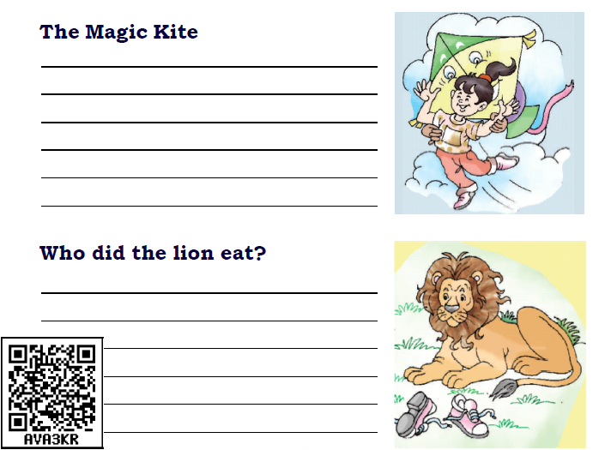


LESSON – 10

HALDI’S ADVENTURE
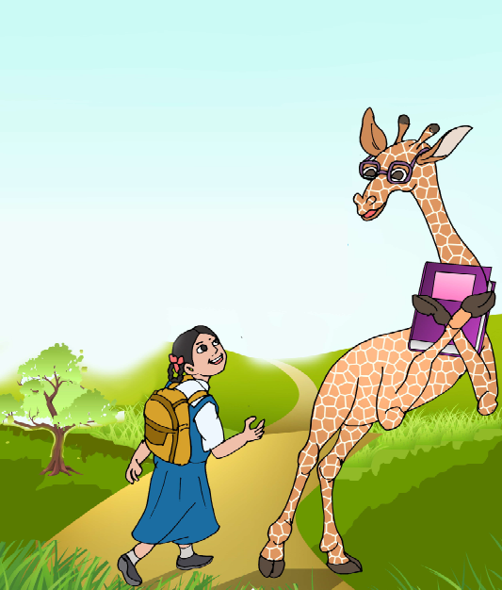
One morning, as Haldi walked to
school, she met a giraffe. The giraffe wore
big glasses and held a book in his hand.
He smiled and said, “Good morning,
Haldi.”
Haldi looked up at him. “I’m sorry to
stare,”she said, “but I have never met a
giraffe like you.”
“My name is Smiley,” said the giraffe.
“Whenever you see me, you will smile.”
Haldi was surprised and happy too.

Then she remembered that she would be late for school.
So she said to the giraffe, “I would love to talk to you but I must rush to school or I will be late.”
The giraffe said, “Not if you ride on my back. If you climb on my back, I will run so fast that you will feel you are flying to school. Do you go to school every day?”
“Yes,” said Haldi. “I go to school on Mondays,Tuesdays, Wednesdays, Thursdays and Fridays. On Saturdays I play games at school.”
“What do you do in school?” asked the giraffe. “I learn about the stars, the trees, the birds and the animals.”
“That is good,” said the giraffe, “I love books too. They are lots of fun. Now jump on my back. I will take you to school.”
Haldi then jumped on the giraffe’s back and found that she could see so many things from the top. And before she knew it she had reached the school playground. She climbed down. When she turned back to thank the giraffe, she found that he had gone away.
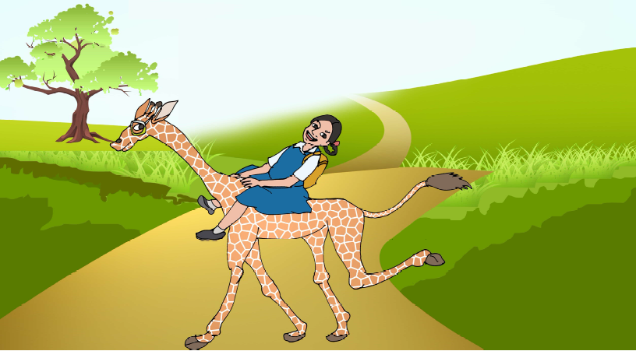
“Oh!” Haldi thought. “What a wonderful adventure I have
had!

I. New words
surprised, adventure, wonderful, stars, whenever

II. Read and write
Read the story carefully and answer the questions:
1. Write the names whose picture is given below


2. Complete the dialogue.
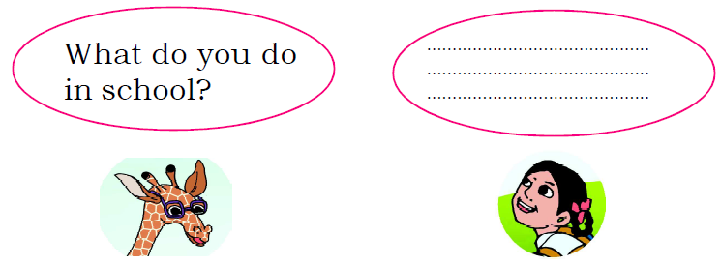

3. Write whether the given statement is true or false.
(i) The giraffe had a book in his hand.
(ii) Haldi was surprised and happy to meet Smiley.
(iii) Haldi reached the play ground quickly.
(iv) The giraffe took the girl to school on his back.
(v) The giraffe attended the school with her.
4. Where was Haldi going?
5. Whom did she meet on the way?
6. Why was the name of the giraffe ‘Smily’?
7. Does Smily love books?
8. Who said this?
(a) “I am sorry to stare.”
(b) “Whenever you see me, you will smile.”
(c) “I love books too.”

III. Say aloud
giraffe, walked, smiled, glasses, stare, whenever, surprised,
Wednesdays, reaches, turned, wonderful, adventure

IV. Let’s talk
1. Whom did Haldi meet while going to school?
2. Describe how the giraffe was looking?
3. Have you seen a giraffe? Where did you see it?

V. Vocabulary
Fill in the blanks with suitable words given in the help box.
(adventure, stars, surprised , wonderful, stare, whenever)
1. It is a bad habit to ......................... at somebody.
2. Mountain climbing is an ......................... for many people.
3. I travelled in an aeroplane. It was a ............... experience.
4. Mohit had helped me ......................... I asked him.
5. Nidhi writes with both hands. I was ...................to see that.
6. The sky was clear and the ......................... were twinkling.

VI. Structures in the context
Look at the picture and use correct describing words before the words given below.
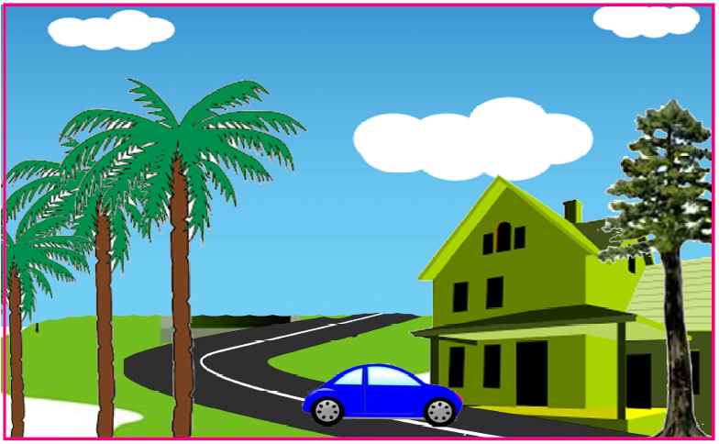
white cloud tall tree big house
pretty flowers blue car

Notes : All the underlined words are describing the following
nouns. These describing words are called adjectives.

(A) Make a phrase using the following adjectives :
1. round .......................................
2. pretty .......................................
3. hot .......................................
4. red .......................................
5. beautiful ......................................

(B) Arrange the given sentences in their place to complete
the story :
He asked me to go with him
but I must ask my father first.
I was surprised
I met a young man.
I was sorry to say
One morning, as I walked to school, ................................. He looked at me and called me by my name........................... how he knew me. ............................that I did not know him. He told me that he was my relative. .......................... to the near by city shop so he could buy some toys for me.
I said, “ Thank you, It would be fun. I would love to come with you ..................................................”

VII. Let’s sing
The giraffe is so big and tall
Its head is high and eyes are small.
It can see things all around,
And eat the leaves far above the ground.

Teachers may use this poem for listening activity. He/she will make the students circle the words he pronounces separately.

VII. Fun time
Learn to make a word-web. Make lines to join the boxes outside to the box in the centre
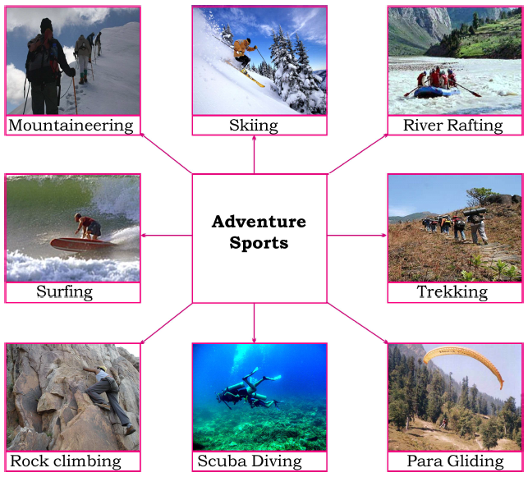
(C) Make a word-web of sources of water :
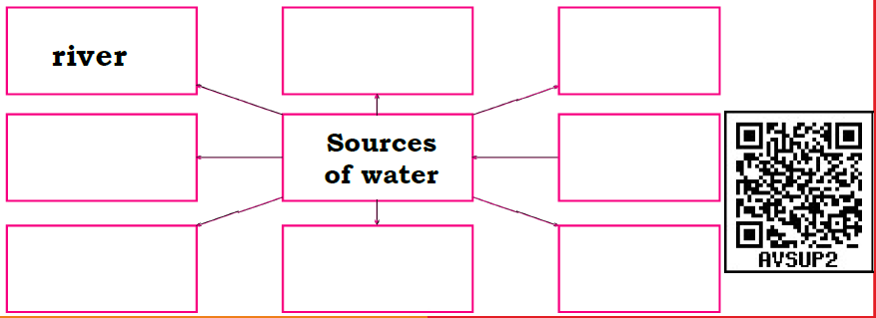


LESSON - 11

MY COMPUTER

I have a magic box
We call it the computer.
All you do can be seen
On its monitor
It has a keyboard
And is run by a mouse
It has a processing unit
which is the brain house.
You can see me hear songs
with the headphone on
And if you want it louder
There are speakers full-on
I can play games on it
And solve many riddles,
Paint and draw and build
And get answers to puzzles.
I type my name on the keyboard

And you know what is more,
It comes out of the printer
And I can paste it on my door.

I. New words
computer, monitor, keyboard, headphone, mouse, processing unit (C.P.U.), full on , paste, printer
II. Read and write

1. Lable the parts of the computer.
2. Where do you put a CD into a computer?
3. Where will you type your name and where can you
see it?
4. What does the mouse of the computer do:
(a) It runs (b) It clicks (c) It speaks (d) It eats cheese
III. Let’s talk
1. Do you use a mobile?
2. Make a list of things that you can do on your mobile.
3. Have you ever seen a computer?
4. Where have you seen it?
5. Should we all know how to use a computer? Why?
6. Do you have a computer in your school?
IV. Let’s learn
Do you know the difference between biography and autobiography?

Biography  A biography is the story of a person’s life which is written by somebody else.  Example :  1. Mahatma Gandhi  by-Vinobha Bhave  2. Bhagat Singh: The Eternal  Rebel by- Malwinderjit Singh | Autobiography  An autobiography is the story of a person’s life which is written by the same person.  Example :  1. Wings of Fire- Dr. APJ Abdul  Kalam  2. The Race of My Life-  Milkha Singh

Here is an autobiography of a mango tree.

An Autography of a Mango Tree

I am a big mango tree standing on the backyard of Mr. Raghu. Once I was just a small seed. Mr. Raghu bought me from a market and sowed in his backyard. He watered me regularly and tended me carefully. Soon I turned in to a big tree with strong branches and densely green leaves. Now I bear sweet juicy fruits on me. Children, young, old and even many birds all love to eat my fruits. In summer people take rest under my shades.
Children love to play hide and seek on my branches. I am a home for many birds and other creatures. We all live happily together.

1. Write an autobiography of a computer.

V. Fun time
(A) Read the message on the cellphone and write your reply.

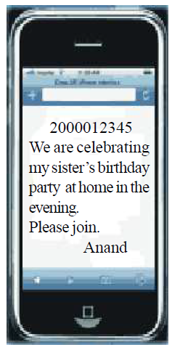

(B) Write a reply to this message.
......................................................................
......................................................................
......................................................................
(C) Write another message like this to your friend.
......................................................................
......................................................................
......................................................................

(D) Think that you are a computer. Write some-thing about yourself and share it with your friends.


LESSON – 12

THE MAGIC PORRIDGE POT
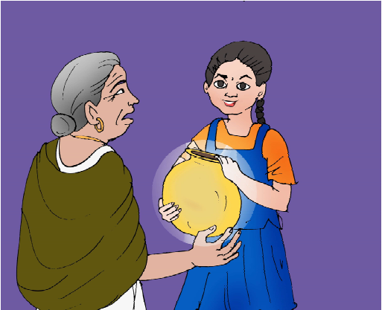
Once, there was a little girl named Tara. She lived with her mother. They were very poor.
One day she went to a forest. There she met an old woman.
The old woman gave her a pot. She said,
“This is a magic pot. It will cook porridge for you when you say, ‘Cook-Pot-Cook’. It will stop making porridge when you say, ‘Stop-Pot-Stop’.”
Tara was very happy. She ran to her mother and said,
“Mother, we will no longer be hungry as I have got a magic
pot.”
Tara said to the pot, “Cook-Pot-Cook” and the pot cooked porridge. Her mother was very happy and they both ate porridge.
One day, when Tara had gone out, her mother felt hungry. She said to the pot, “Cook- Pot-Cook.” The pot started cooking porridge.
After eating it her mother said, “Do not cook pot.” But the pot went on cooking.
Soon the porridge started spilling on the floor.Mother called out again,”Wait - do not cook anymore.”
But the pot did not stop.

Mother ran out of the house and porridge followed her. Soon there was porridge everywhere. The whole village saw it. They ran to eat the porridge. When Tara came back, she saw that the road was full of porridge. She ran home as fast as she could. She heard her mother shout, “Tara the pot is cooking and it will not stop.”

Tara called out, “Stop-Pot-Stop” and it stopped cooking porridge.
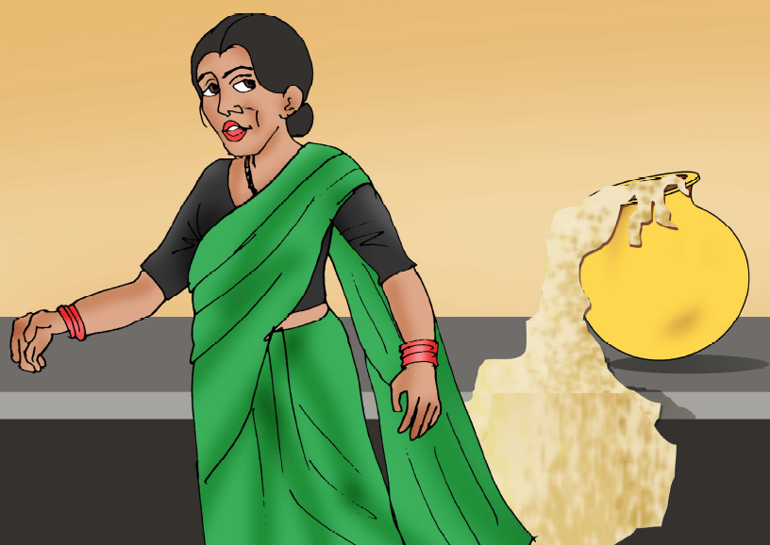
-A folk tale
I. New words
magic, cook, porridge, spilling, whole, village

II. Read and write
Answer these questions:
1. Where did Tara go one day?
2. What did the old woman give Tara?
3. What did the magic pot cook?
4. What did Tara say to the pot to cook porridge?
5. Who said “Do not cook pot”?
6. Why was there so much porridge on the road?
7. What had Tara to say to stop making porridge?

III. Let’s talk
1. What do you eat for your breakfast?
2. Would you like to eat wheat porridge?
3. Have you seen any magic? Tell us about it?
4. What do you call magic in your own language?
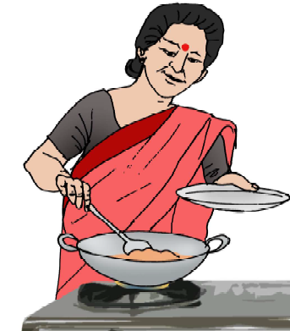
IV. Listen & recite
Peas porridge hot
Peas porridge cold
Peas porridge in the pot
Nine days old
Some like it hot
Some like it cold
Some like it in the pot
Nine days old
V. Vocabulary

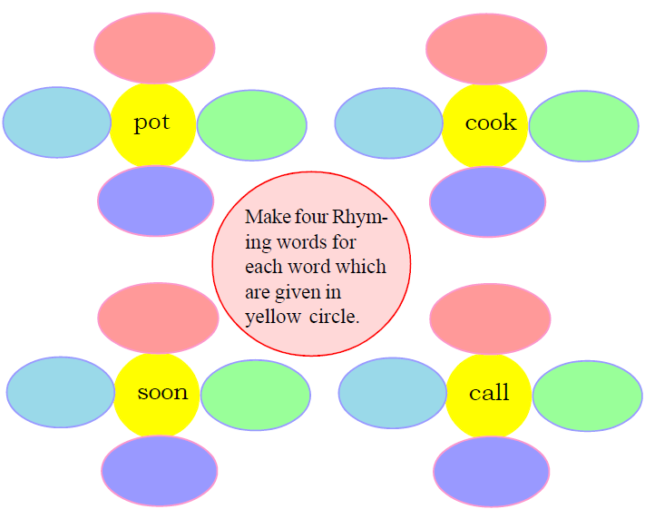

Look at the letters given below and make words starting with them.
k ................ ................ ................
p ................ ................ ................
j ................ ................ ................
t ................ ................ ................
m ................ ................ ................

VI. Let’s learn and practise
In TV channels we often watch interview with persons. An interview is a meeting at which one asks questions about ones life, ones opinions on certain issues.
An Interview with Grandfather:
Rani : Good morning, Dadaji!.
Grandfather : Good morning, Rani? Nice to see you! so early in the morning! Is there something special today?
Rani : Yes, Dadaji. It’s very special. I will interview you today.
Grandfather : What is that?
Rani : I will ask some questions about you and you will
answer them.
Grandfather : O.k, I am ready.
Rani : When and where were you born?
Grandfather : I was born in my mother’s village, Nawagaon near Nawapara Rajim on 4th April in 1955.
Rani : By what name did your parents call you?
Grandfather : They used to call me Chhotu. Since I was
the youngest among my four brothers and two sisters.

Rani : How old were you when you started school?
Grandfather : I was seven years old.
Rani : Were you a good student?
Grandfather : Ofcourse, I was.
Rani : What is your education?
Grandfather : My education is up to class 10 th.
Rani : What did you want to be?
Grandfather : I wanted to be a farmer and that is I am.
Rani : What is your hobby?
Grandfather : My hobby is gardening.
Rani : Thank you, Dadaji! Everybody will share the
interview in the class tomorrow. So will I. It is very
interesting.
Grandfather : Thank you, my child! It’s the first interview
I ever faced.

Interview the persons around you and in your locality e.g.
your grandmother, class teacher, your headmaster, your
English teacher, the Sarpach of your village, your family
members, a carpenter, a barbar, a plumber, a farmer etc. and share it with your class.

VII. Fun time
Let’s cook porridge.
Your grandmother must be making delicious por ridge. Would you also like to learn how to make it? Ask your mother or an older person to help you.
You need – Milk, porridge, sugar
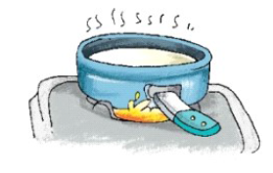
- Take hot milk.


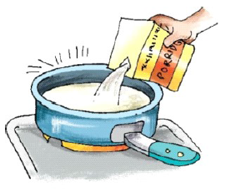
- Add cooked porridge.

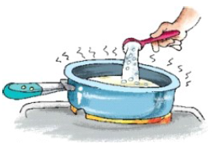
- Add sugar and eat it.

1. Repeat this recipe in your language to the class.
2. Give instructions to make tea.


LESSON – 13

HE IS MY BROTHER
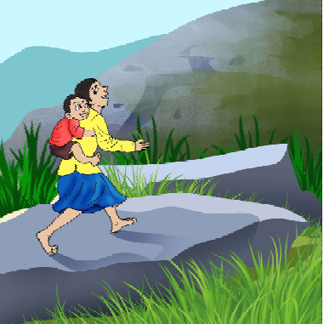
Once upon a time there was a small hill. A path went up the hill.
It went through thick and lovely woods of pine and fir trees. People often walked on it to a holy place.
One day when the sun shone high in the sky, many people were seen climbing up the hill. They were climbing slowly and carefully.
A girl also climbed the hill with them. Her name was Meena. Meena was twelve years old. She carried a small boy on her back.He was four years old. His hair was curly. His eyes were black and his face was as fresh as the morning dew.
As the sunshine danced through the trees, Meena climbed the hill slowly and steadily. Meena was happy. The boy was also happy.
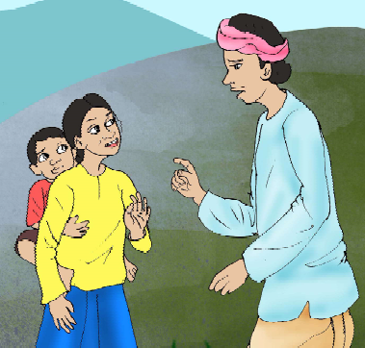
A man in the group looked at Meena. He felt sorry for her. He asked her, “My child, why are you carrying the boy on your back? Don’t you feel his load?”
Meena looked at him in wonder. She could not understand him. (Her brother was unable to walk). Meena asked, “Load? Of course not! He is my brother!”
I. New words
understand, climb, holy, dew
II Read and write
(A) Answer these questions :
1. Where were the people going?
2. What did the man say to Meena?
3. Why do you think Meena was carrying her brother?
(B) Choose the correct answer :
(i) The path went .............. :
(a) up the hill.
(b) down the hill.
(c) away from the woods.
(d) between two hills.
(ii) Which statement is not correct about
Meena’s brother :
(a)Meena’s brother is four years old.
(b)He was tired.
(c)He couldn’t walk.
(d)He enjoyed the ride on the back.
(iii) Meena didn’t feel any load on her back because
:
(a) she was beautiful.
(b) she didn’t carry any load.
(c) she was 12 years old.
(d) she was carrying her brother on her back.

III. Let’s talk
Do you help your family members in their work?
(i) What do you do for your mother?
(ii) How do you help your father?
(iii) When do your friends ask for help?

IV. Vocabulary
(A) 1. The rat ran in when the cat ran -----------
2. The lion is big but the ant is----------

(B) Underline the word in the group which is not related to the given word.
understand : know, follow, do, under
holy : sacred, whole, pious, religious
dew : drop, cold, fresh, hot
woods : would, jungle, forest, trees
load : heavy, tiny, big, burden

(C) Rearrange the letters to make words:
b c m l i
r n o w d e
l r y c u
h r e f s
e p l o p e

V. Structures in context
Read the sentences:
• People were climbing carefully.
• Meena climbed the hill slowly.
• Rani Laxmi bai fought bravely.
• Mrs. Sudha speaks softly.

Words that tell us something more about a verb or action are called adverbs like climbed slowly, speaks softly and fought bravely.

(A) Fill in the blanks with the correct words from the brackets :-
1. They danced on the floor ___________. (beautiful/beautifully)
2. She knows the road ___________. (good/well)
3. She speaks very___________. (quiet/quietly)
(B) Write adverbs of the following adjectives:
1. noisy - __________
2. clear - __________
3. beautiful - __________
4. slow - __________
5. tidy - __________
6. lucky - __________
VI. Class activity
Write your name and write a word for each letter. The word must start with the same letter.
e. g. : My name is SUMAN. There are five letters in my name.
S - sugar
U - umbrella
M - mouse
A - apple
N - nose
Teacher may ask students to write words giving different conditions such as:
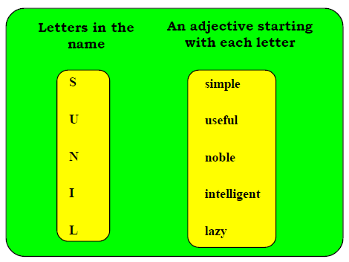

(1) Each word should have three letters.
(2) Each word should have four letters.
(3) Each word should be a doing word.
(4) Each word should be an adjective.
(5) Each word should be noun.

VII. Let’s Learn
1. Write a letter to your grandmother. Tell her about your studies and about the competition in which you are taking part.

Ward 15’  Near Hanuman Temple,  Raipur. | Your Address
Date / / 2017 | Date

Dear Dadiji
I am well here and hope the same for you there. My Half Yearly Examinations are over. I did well in all subjects. There is an inter-school quiz competition on Chhattisgarh in our school after twelve days. My class teacher has selected me in the team. Dadaji has a good book on Chhattisgarh. Please send it through someone. I do remember the summer acation with you and your dishes like Chila, Fara, Kadhi and Patal chuteny very much. My regards to Dadaji. | Body

Your loving grandson  Sanju | Closing

2. Now, write a letter to your friend or relative in another city
telling him/her about activities/ events in your school. Follow the same pattern as the above letter.

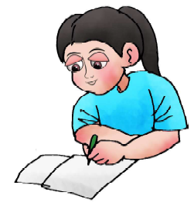



LESSON – 14

I AM LUCKY
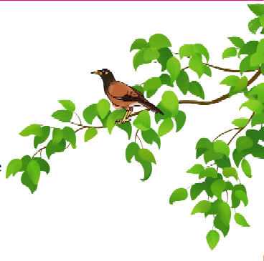
Listen and recite
If I were a butterfly
I would be thankful
For my wings.
If I were a myna in a tree
I would be thankful
That I could sing.
If I were a fish in the sea
I would be thankful

That I can wriggle and giggle with glee.
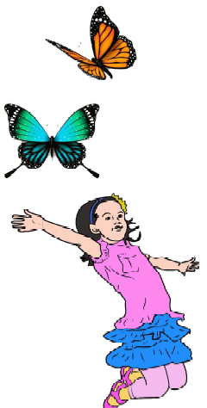
So, I just think I am lucky to be “me”.

Not “you” but “me”
If I were an elephant
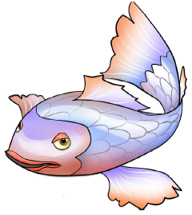
I would be thankful
That I can raise my trunk.
If I were a kangaroo
I would try to go
Right upto the moon

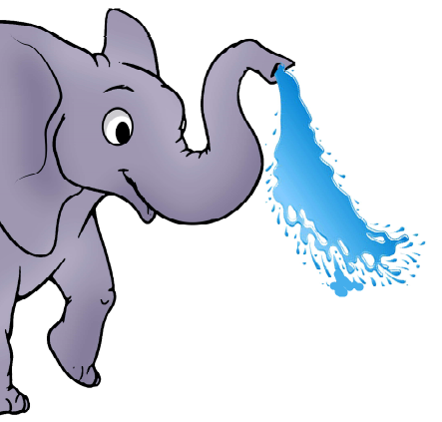

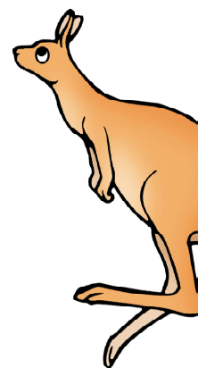

If I were an octopus
I would be thankful
For my eight arms
So, I just think I am lucky to be “me.”
Not “you”, but “me.”
What do you think you want to be?
Do you want to be like me?
Or just you? Just you.......

I. New words
butterfly, myna, kangaroo, octopus,arms

II. Read and write
Complete these sentences:
Animals | Action
A butterfly  …………………..  An Elephant  You | …………………..  Can wriggle  …………………..  …………………..
III. Say aloud
butterfly, thankful, wriggle, giggle, kangaroo,moon, octopus,
arms, just.
IV. Let’s talk
1. Why do you think the butterfly likes its wings?
2. What can the myna do?
3. What can you do-sing/paint/write.....?
4. Do you think the fish was really happy to be in the
water?
5. What are the lucky things that have happened to you?
Tell your friends in the class.

V. Vocabulary
(A) Fill in the blanks using the hint words given below:
hop, roar, swim, fly
1. If I were a kangarro, I would ............... like them.
2. If I were a tiger, I would ................... like them.
3. If I were a fish, I would .................. like them.
4. If I were a bird, I would ................. like them.
(B) Write five other words similar to the first one and
use them in your own sentences :
thank + full = thankful
1. help + full = helpful
2. care
3. beauty
4. use
VI. Structures in context
Complete the sentences.
1. If I were the head of the village, I would ...................
..............................................................................
2. If I ...................................... I would fly in the sky .
3. If I were your brother I would .................................
..............................................................................
4. If I were a tree I would ............................................
VII. Let's Write
Write your answer in five lines.
Why are you thankful to God ?

VII. Fun time
Here is the story “Foolish Goats, Wise Goats”. It has been divided into four parts and put in jumbled order. Look at the pictures and write a number in the circle acording to its sequence.

Pintu and Mintu were two  wise goats. They did not  fight. Gotu sat down and  let Lotu cross first. | 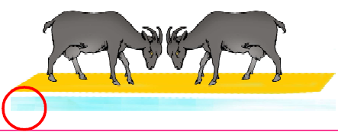
This way Pintu and Mintu  both reached the bank  safely. | 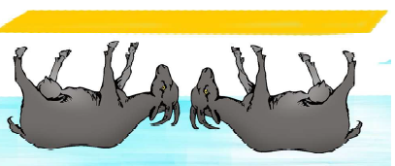
Pintu and Mintu fought  and both fell into the river. | 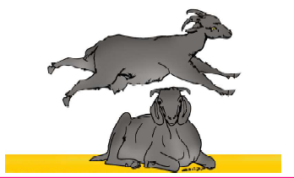
Two foolish goats Pintu  and Mintu wanted to cross the bridge first. | 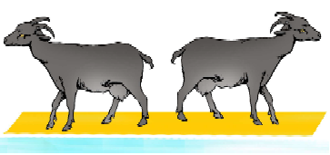



LESSON – 15

THE MISER
Once there was a very rich man. He was a miser. He ate very cheap food and spent very little money. He lent money to small shopkeepers at a high interest. In this way he earned a lot of money. Every morning he went out to see the shopkeepers and came home at midday.
The miser had a watchman to look after his house.
The watchman lived in a hut near the gate. He liked fish and his wife cooked it for him every day. The watchman told his wife, “Cook the fish before midday. Our master will be out then. He doesn’t eat meat or fish and he will not like the smell of fish.”
One day, the master came home early. He walked past the watchman’s hut and caught the smell of fish. It was a nice smell and he liked it very much.
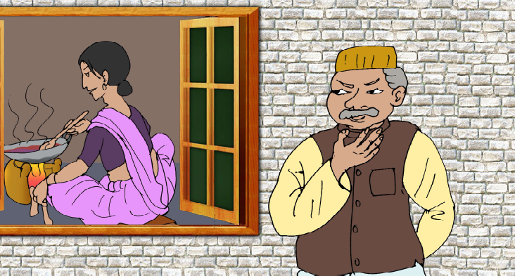
That afternoon he called the watchman and asked him,
“What were you cooking today?”
The watchman said quickly, “I won’t do it again, Sir.
Please excuse me.”
The miser said, “Don’t be afraid. I am not angry.”
What was your wife cooking? Please tell me.”
The watchman said, “We were cooking fish.”
The miser said, “Please cook it every day. I like the smell very much.”
The watchman and his wife thought, “Our master is
mad.” But they cooked fish every day.
After a month, one evening the watchman and his wife
came to see their master.
“Sir, you like the smell of fish,” the watchman said to his master, “So we cook it every day. But fish is not cheap. It is very costly. It costs us a lot of money. I earn only thirty rupees a month. So please give us money for the fish.”
The miser thought for a while. Then he said, “Oh, all right. Wait here.” He went into his room and shut the door behind him. He took out some silver coins from a bag. He
dropped them one by one on the floor. The watchman and
his wife heard the tinkle of the coins and were very happy.
They said, “He is going to give us all that money.”

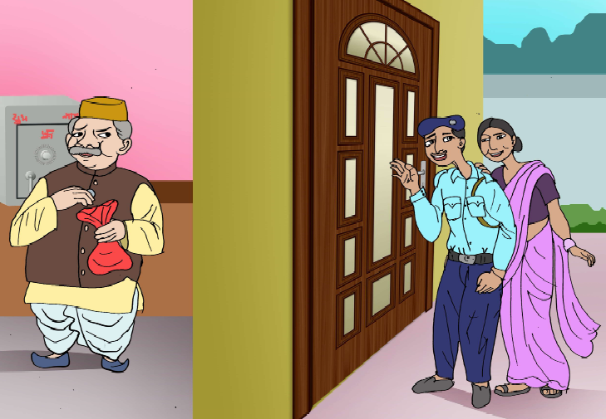
After some time their master came out and sat down on a chair. He then asked the watchman and his wife.
“Did you hear the tinkle of the coins?”
“Yes, sir, we did.” Said the watchman.
“Did you enjoy it?” asked the miser.
“Yes, sir,” said the watchman and his wife.
The miser then said, “Alright, I enjoyed the smell of
your fish and you enjoyed the sound of my coins. I don’t ask for your fish, so you don’t ask me for money. Now go away.”

- New words
coin, meat, midday, tinkle, while, lend, excuse, one by one

II. Read and write
(A) Answer these questions:
1. How was the rich man?
2. Who did he lend money to?
3. What did the watchman’s wife cook everyday?
4. Did the miser like the smell of the fish.
5. The miser enjoyed the smell of the watchman’s fish. What did the watchman and his wife enjoy?
(B) Who said and to whom:
1. “Cook the fish before midday”, ……..…….said to …………
2. “Please cook it everyday. I like the smell very much.”
………… said to ……………….
3. “He is going to give us all that money.”…….. said to……………..
4. “Did you hear the tinkle of the coins?”…………. said to
……………
III. Say aloud
miser, shopkeepers, interest, earned, midday, cooked, fish, walked, l iked, excuse, costly, dropped,tinkle, coins, alright, enjoyed, won’t.

IV. Let’s talk
(1) Work in pairs:
- Ask your friends questions about all the thing she or he does.
- Use question words such as where, what, how, who,
when, why, (One is done for you).
Ranu : I take my lunch at 12 O’clock
Manju : When do you take your lunch?
Ranu : I play in the ground
Manju : ...............................................
Ranu : I go to school at 9.45 a.m.
Manju : ............................................
Ranu : I take rest at home on Sunday.
Manju : ................................................
Ranu : Bablu is my brother
Manju : .................................................

V. Vocabulary
meat, while, coin, shut, tinkle, enjoyed, interest,
smell, wait, excuse
1. I felt pity for the beggar and give him a …….. of five
rupees.
2. I am vegetarian. I don’t eat ……… .
3. The greedy man loves the ………… of coins very much.

4. Please do not disturb me ……….. I am at work.
5. The student said, “ Sorry, I am late. Please excuse me
this time.
6. Sushant gave a birthday party in the school canteen.
We all …………. it very much.
7. I am not coming today. Please do not …… for me.
8. ………….. the door or any animal may enter the house.
9. I can lend you money at the rate of 12 percent …….
10. I don’t like the strong ……… of garlic.

VI. Vocabulary
(A) Match with the correct antonyms :- (opposites) :
miser — sad
cheap — slowly
quickly — spendthrift
shut — costly
happy — servant
master — weak
strong — open

(B) The words in the circle describe something or someone in the story. Name them in the blanks provided.
Make sentences of your own with the words in the box.

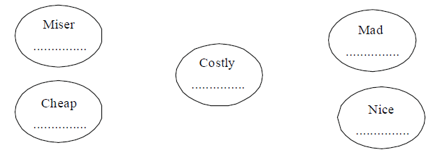

VII. Structures in context
(A) Grammar Notes:
At : specific time : Ex.- 7 O’clock, 8.30 a.m
Holiday period: Ex.- at chrismas. Night
In : Ex.-Morning. Evening
Year, month. season Ex.- in 1998, in winter

(B) Fill in the blanks using ‘in’ or ‘at’ :
1. Aasim goes to school ............... the morning.
2. Mahak plays with her friends .......... the evening
3. He comes home for lunch .............. midday.
4. His school ends .................. 4 p.m.
5. Bunty wakes up ........ 7 O’clock in morning.
6. My younger brother was born ....... 2006 ....... the
month of January.
7. The train arrived ..... 3.30 pm.

VII. Fun time
This picture story has been jumbled up. Write the digit 1 to 4 in the circle to show the correct sequence of the pictures.
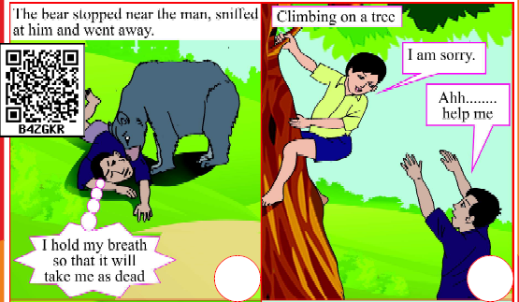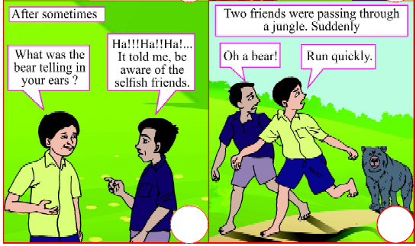


LESSON – 16

NINA AND THE BABY SPARROWS

There was great joy in Nina’s house. Nina’s aunt was getting married. Nina, her father, mother and little brother were all going to Delhi for a wedding. Everyone was happy, except Nina.
Her mother took her to the market to buy a new dress. “What colour would you like?” Mother asked.
“I don’t want a new dress, Mother,” said Nina. Salwarkameez then?”
Nina shook her head.
“What about those lovely white shoes you saw last week?”
“I don’t want those, either. Thank you, Mother.”
Nina’s mother was
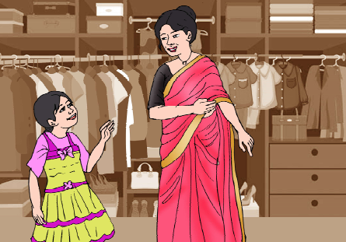
upset, but she said
nothing. They went
back home and had
lunch. After lunch
mother came and sat
near Nina. “What is it,
child?” she asked.
“Why did you say ‘no’
to everything?”
“Mother, I don’t
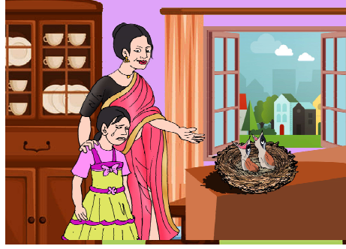
want to go to the wedding.”
“But why?”
Nina said nothing
Instead, two big tears
rol led down her
cheeks. Mother put
her arms around
Nina. Don’t cry, my pet.” she said. “why don’t you tell me
what’s bothering you?”
More tears rolled down Nina’s cheeks. “Mother.” she said,
“there’s a sparrow’s nest on the bookshelf in my room. And
there are two baby sparrows in the nest.”
“I see .........”, said mother.
“They’re just beginning to get their feathers. And growing
up makes them so hungry. All day long they cry ‘cheep-cheep’,
asking for food.
“I see! said Mother.
“If we go, the whole place will be locked. And how will
papa and mama sparrows feed their babies?”
“Oh Nina“, cried Mother, giving her a big hug. “Is that why
you don’t want to go to the wedding? But that’s no porblem
at all, we’ll leave the window open.”
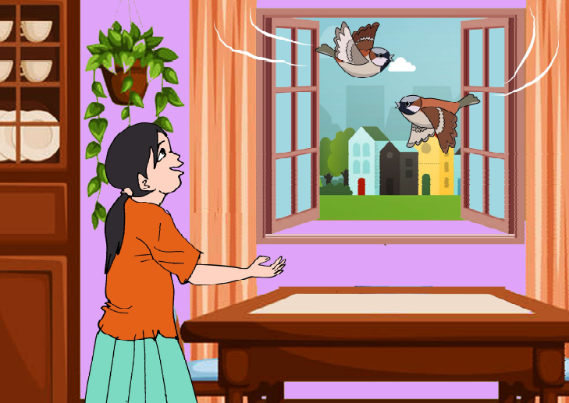

“Oh, can we, Mother? Can we? Really?”
“Yes, yes. we’ll remove all your things from the room and lock the door on the outside. So the house will be perfectly safe and papa and mama sparrow can come and go freely, too. Just think, Nina ...... while you enjoy yourself at the wedding, the baby sparrows will be getting nice and fat in their nest. Good idea, isn’t it?”
It was a good idea. When Nina came back from the wedding, there were two plump little sparrows flying all over the room, And wasn’t Nina thrilled!

- New words
joy, bother, marry, upset, feed, remove, wedding, shake, hug, instead, plump, thrilled
- Read and write
1. Why was there a great joy in Nina’s house?
2. Why was Nina worried?
3. What did mother suggest?
4. What did Nina find when she came back from wedding?
5. Write a few lines about Nina.

- III. Say aloud
joy, married, white, either, bothering, hug, problem,
remove, perfectly, freely, plump, thrilled

- IV. Let’s talk
What will you do for the solution of the given
Problems

If I have this problem | I will do this
(1) If I am ill  (2) If I don’t understand  anything in the class  (3) If someone fights with me  (4) If any unknown person  asks me to go with him.  (5) If anyone touches me  how I don’t like | I will go to a doctor.  I will ..................... .

V. Vocabulary
(A) Fill in the blanks with the suitable words from the help box:
dress, bookshelf, window, married, happy, sparrow
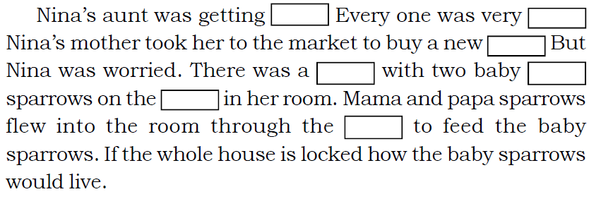

(B) Match the words with their antonym:
problem sorrow
bother add
joy comfort
remove solution

(C) Use the following words in your own sentences :
wedding, upset, hug, instead
VI. Structures in context
Contractions: shortening or words
Look at these sentences.
'I'm a student. I'll go to school.'
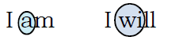
The words I'm and I'll are short forms of I am and I will. They have been shortened to make one word by removing the a and wi and putting an apostrophe (') in its place.

There are many words like these which can be shortened.
Look at this table to understand how some words are shortened.
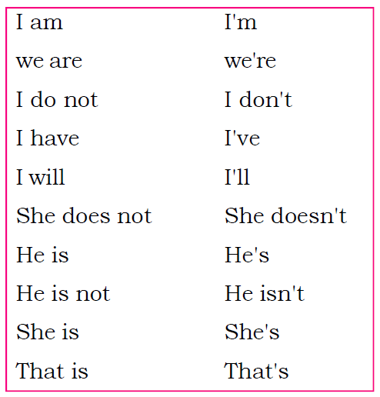

VII. The tenses
Tense means time.
Time is expressed by using the correct form of the verb in a sentence.

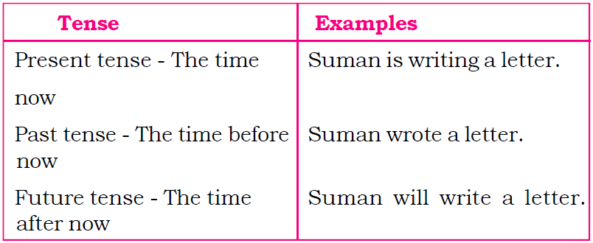

Complete this table. Write the correct forms of the verbs. One has been done for you.
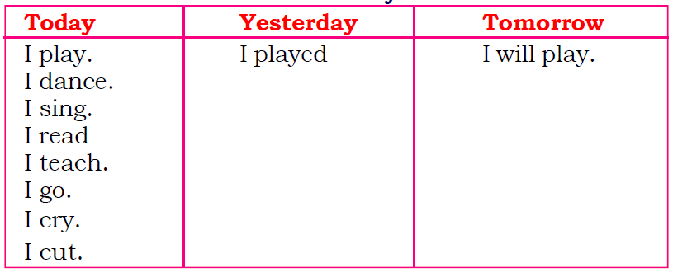

VII. Fun time
- Would you like to have birds visiting you everyday? What would you do for that?
- Try making a bird-bath and a feeding corner for birds.
- You can place a bowl of water in a quiet corner of the house.
- Leave bread crumbs, grains etc. for your feathered friends.
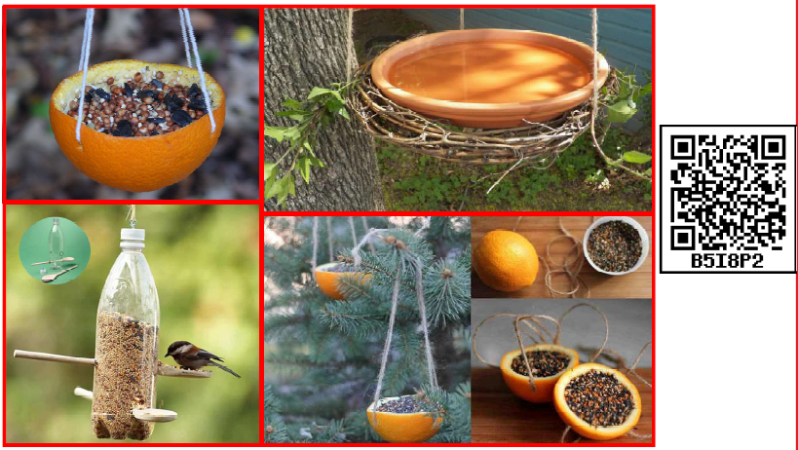
Look at the pictures and write the name of things you need to make them.

